Assignment (N+) Ethernet
Task-1:
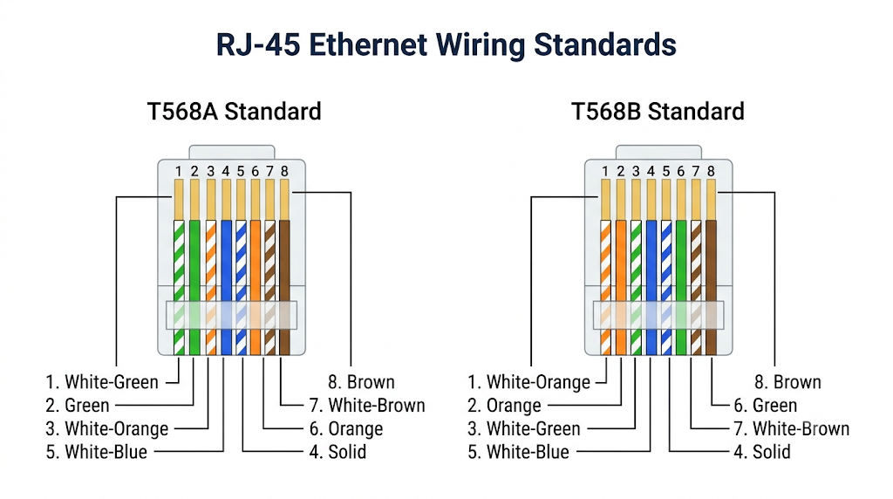
Task-2:
Standard | Speed | Cable Type | Max Length | Connector
10BASE-T | 10 Mbps | Cat3 UTP | 100 m | RJ-45
100BASE-TX | 100 Mbps | Cat5 UTP | 100 m | RJ-45
1000BASE-T | 1 Gbps | Cat5e UTP | 100 m | RJ-45
Task-3:
To connect two laptops directly, the traditional and mechanically correct choice is a crossover cable.
Because both laptops are identical devices, their network cards transmit (Tx) and receive (Rx) data on the exact same pins.
If you used a straight-through cable, the transmit pins of one laptop would send data directly into the transmit pins of the other, causing a collision.
A crossover cable solves this by physically crossing the transmit wire pairs on one end to connect to the receive pins on the other end.
This ensures that the data signal sent by the first laptop is successfully caught by the listening pins of the second laptop.

Task-4:
- Wi-Fi Router:
Typically supports 1000BASE-T (Gigabit Ethernet) on its WAN and LAN ports to handle high-speed broadband internet and distribute it to multiple connected devices without bottlenecking.

- Desktop Computer (College Lab):
Most modern PC motherboards come equipped with a 1000BASE-T Network Interface Card (NIC) to ensure fast access to central campus servers, large software downloads, and shared network drives.
- Smart TV:
Many Smart TVs use 100BASE-TX (Fast Ethernet) rather than Gigabit connections. A 100 Mbps connection is more than sufficient for streaming 4K video (which only requires about 15-25 Mbps), allowing manufacturers to keep hardware costs down.

